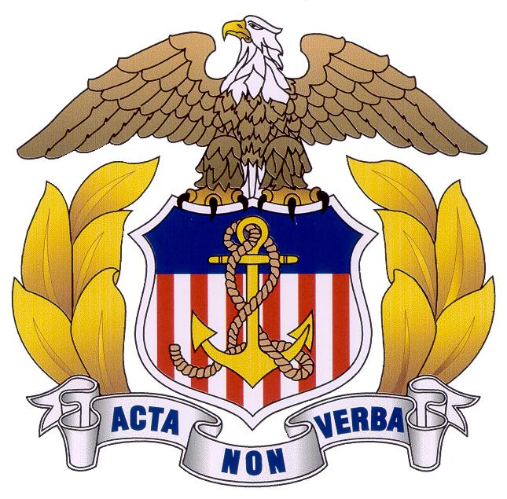
UNITED STATES MERCHANT MARINE ACADEMY
2018 ACCEPTANCE WEEKEND
FRIDAY 8 AUGUST – SATURDAY 9 AUGUST

Enclosed is my check for $___________ to purchase Meal Tickets for Acceptance Weekend.
Please make your check payable to: “Crystal Enterprises Inc”.

Deadline for purchasing meal tickets is 31 July 2014.
Mail this form with your check to

Ms. Frantze Nell
Office of the Commandant
US Merchant Marine Academy
300 Steamboat Road
Kings Point NY 11024

Name(s) of Plebe Candidate(s)

 | Number of Tickets  Requested | X | Amount | Total | Check Number
Box Lunches |  | X | $11/each |  | #
Dinner In Delano |  | X | $16/each |  | #

If purchasing tickets for both meals you need only send in one check to cover the total.

