**Dean’s MSCHE Self-Study Advisory Board**

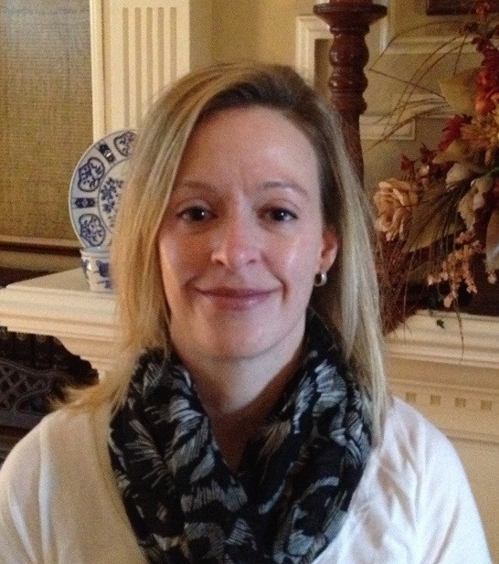

*Dr. Lori Townsend: MSCHE Accreditation Liaison Officer, Director of Institutional Assessment.*

Dr. Lori Townsend joined USMMA in May of 2016.  Her educational credentials include a Doctor of Education (Ed.D.) degree in Higher Education Leadership and Policy from Vanderbilt University, a Master of Business Administration degree from Strayer University, and a Bachelor of Science degree in Medical Technology from Old Dominion University.  She has worked in higher education since 2006 in various roles including Assistant Dean of Student Services, Director of Admissions, Director of Financial Aid, Director of Enrollment Management, Registrar, and Bursar at a small, not-for-profit college of health sciences; and Federal Student Aid loan supervisor at a large community college system. Currently, Dr. Townsend serves as the Academy’s Accreditation Liaison Officer (ALO) to the Middle States Commission on Higher Education (MSCHE) and ensures all reporting and accreditation processes are conducted within the required timelines.

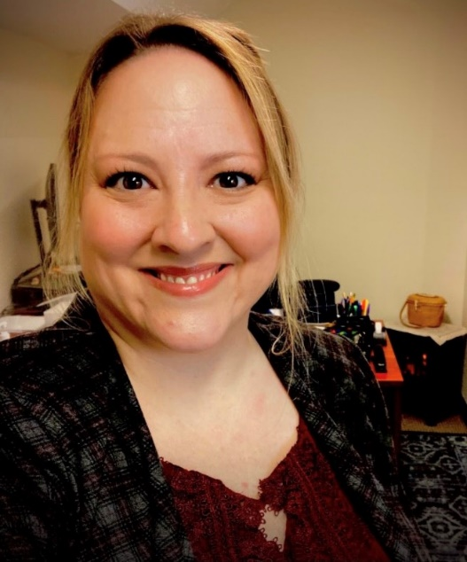

*Dr. Jennifer Albert: MSCHE Self-Study Steering Committee Chair, Deputy Director of the Academic Center for Excellence.*

Dr. Jennifer Albert brings over 20 years of experience in the higher education and K-12 sectors, as well as community engagement and government relations to her role as Academic Counseling Specialist at USMMA. Her various professional roles include Partnership Specialist for the United States Census Bureau; college Dean of Students; Director of the New York State Opportunity Program HEOP; Director of Student Support Services inclusive of the offices of Residential Life, Student Activities, College Counseling, Veterans Services, and Special Needs programs; and Associate Professor of English, Psychology, and Education.

She has chaired, co-chaired or been a member of various committees, including the President’s and Provost’s Cabinets, Middle States Accreditation Steering Committee, Academic Standards, Student Conduct, Title IX, Curriculum & Instruction, and Freshman Experience. She has also served as Superintendent and Head of School for a private secondary school serving both domestic and international students. Additional areas of expertise include academic policy and procedure, student retention and completion, college curriculum design, professional development for support staff and classroom teachers, and not-profit program management.

Dr. Albert holds a PhD in Higher Education Administration, an MA in English, and a BA in Psychology and Creative Writing. She is passionate about ensuring that the experience of education for all students is maximized. She specializes in comprehensive success plans that bridge and balance intrinsic knowledge, natural talent, and personal strengths with academic achievement, campus resources, civic engagement, career goals, and global mindedness. She is proud to be a member of the USMMA community, and especially to collaborate with colleagues and students who hold academic excellence and service to our country in the highest regard.

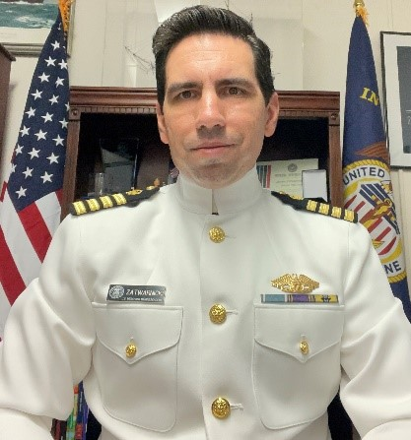

*Captain James Zatwarnicki: MSCHE Self-Study Steering Committee Co-Chair, Associate Dean for Faculty, Associate Professor of Nautical Science/Marine Transportation Department.*

Capt. Zatwarnicki was raised in Clark, NJ.  He graduated SUNY Maritime College in June, 2002 with a degree in Marine Transportation Management and actively sailed on his license from June of 2002 until April 2018. Capt. Zatwarnicki completed his Master of Science in International Transportation Management with SUNY Maritime College in 2017 and is presently pursuing a PhD in Leadership for Higher Education.  He also holds a license as Master, Unlimited Tonnage, Oceans and Master of Towing Vessels.

Capt. Zatwarnicki sailed with Master’s Mates, & Pilots aboard container ships and research vessels for several companies including Maersk Line Limited, Lamont-Daugherty Earth Observatory, Horizon Lines, and APL. In 2010 Capt. Zatwarnicki spent several months working as a Marine Operations Logistics Manager for the Marine Spill Response Corporation on the MC 252 Deepwater Horizon oil spill.  Most recently Capt. Zatwarnicki was employed with Patriot Contract Services where he served as Chief Mate and Relief Master aboard LMSRs.

Capt. Zatwarnicki began working at the US Merchant Marine Academy as an Assistant Professor of Nautical Science in April, 2018.  He has taught courses in Introduction to Nautical Science, Terrestrial Navigation, Ship Stability & Construction, ECDIS, and Bridge Resource Management since then.  In October 2020 he assumed the role of Assistant Dean for Support Programs at the Academy, then Associate Dean for Faculty Affairs in April, 2023.  In June, 2023 he was also promoted to the rank of Associate Professor.  Upon the retirement of RDML John Ballard in August 2023 he assumed the role of Acting Provost.

Capt. Zatwarnicki is very active with the Sea Scouting program, a division of the Boy Scouts of America.  He has been affiliated with Ship 228, the Sea Dart II, in Rahway, NJ since he was 12 years old.  In August, 2022 he helped launch a new program, the Liberty Nautical Education Center, which now provides collaborative educational resources to Sea Scout units in the Greater New York area and helps to connect high school youth to maritime-oriented careers.  He is also a Vice President on the Board of Directors for the Steamship Historical Society of America, Chairman of the Editorial Committee for “Power Ships” magazine, and Board Secretary for the World Ship Society, Port of New York branch.

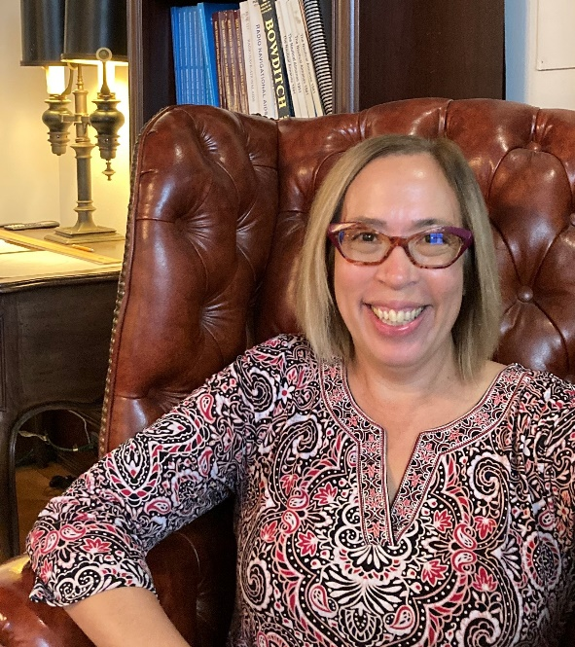

*Dr. Susan Comilang: Dean's Advisory Board Member, Acting Provost, Assistant Dean for Academic Affairs.*

Dr. Susan Comilang brings over 20 years of experience in higher education teaching and administration to her role as Assistant Dean for Academic Affairs at the United States Merchant Marine Academy. Her first appointment at USMMA in September 2015 was as Head of the Department of Humanities. Prior to this she served as the Department Chair of English and Modern Languages at Washington Adventist University. She has taught in the English Departments of Kutztown University, George Washington University, and Washington State University.

Dr. Comilang is excited to bring her experience and knowledge of assessment, curriculum design and best teaching practices to her work as assistant dean, particularly as it pertains to policies and procedures. One of her goals is to help make the educational experience at the Academy as optimal as possible for midshipmen, and she is glad she is part of the expert team of faculty and staff who make this happen. Dr. Comilang has served the Academy on various curricular and assessment committees. She was the Chair of the General Education Committee from its inception in 2016 to spring of 2021. Beyond departmental responsibilities, Dr. Comilang has served on assessment committees at both the program and institutional levels, as well as the Strategic Priority 1 Educational Program Committee.

Along with her interest in assessment and curricular design, Dr. Comilang’s current scholarship concentrates on the concept and lived practices of exile in early modern England. How does exile situate a subject and constitute an understanding of Englishness? How did the Reformation change social construction of space in England and what it meant to belong? Dr. Comilang holds a Ph.D. in English from George Washington University, an M.A. in English from Washington State University, and a B.A. in English from Columbia Union College.

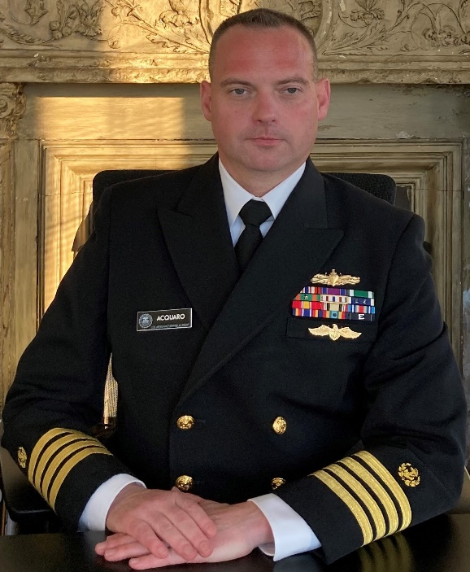

*Captain Paul Acquaro: MSCHE Dean's Advisory Board Member, Director of the Academic Center for Excellence.*

Captain Acquaro has a Bachelor of Science from the State University of New York Maritime College in Marine Transportation with a Humanities concentration, a Master of Science in Education with Distinction from New York Institute of Technology, and Master of Science with an advanced teaching certificate in Students with Disabilities from the City University of New York, Brooklyn College. Not only does he have a Master's Degree in Education, he also holds two New York State Public School Teacher Certifications in Education to include Childhood Education and working with Students with Disabilities. Captain Acquaro is currently ABD for his Doctorate in Business Administration with an emphasis on Higher Education Leadership.

As Director of the Academic Center for Excellence (ACE), his focus is on providing academic leadership, communication, planning, and forward-thinking skills to the midshipmen at the United States Merchant Marine Academy. Part of his portfolio in the ACE also includes facilitating faculty development where he emphasizes skills development in pedagogy and classroom management. CAPT Acquaro has given several presentations on student learning to various professional organizations from the Conference of Service Academies Superintendents to the Symposium of University Research and Creative Expression. He has also been published with regard to student learning and technology, as well as technology in education across the socio-economic statuses.

Captain Acquaro holds Coast Guard Endorsed Licenses both as a Deck and Engine Officer. He has professional experience sailing on both a tanker and container ship as a Third Mate Unlimited Tonage. However, the bulk of his sailing experience stems from his time on active duty in the United States Navy where he served in Engineering Department positions from Electrical Officer to Main Propulsion Officer, culminating as Chief Engineer. His duty stations included time at Commander Naval Surface Force, Atlantic (CNSFUSAF-IG) as the Assistant to the Inspector General; time on the USS Seattle (AOE3), USS Nassau (LHA4) and USS Arleigh Burke (DDG51). He retired from Afloat Training Group, Atlantic (ATGLANT N-82) as an Engineering Readiness Assessment Officer.  While on active duty, his designations included Surface Warfare Officer, Chemical Radiological and Biological Response Officer, Vessel Boarding and Search and Seizure Officer, Strategic Sea Lift Officer, and Shipboard Legal Officer.

Captain Acquaro is committed to providing our midshipmen a challenging but safe environment where they may develop their academic abilities, leadership potential, and social skills. As the member of the Academy’s administration most devoted to retention, his cross-departmental communication is steadfast in student success opportunities. He serves on various committees across the campus and has chaired six major committees during his tenure to include the most recent efforts on the 2024-2031 Strategic Planning Committee.  He is a resident of Long Island, New York where he and wife Stacey have one daughter, Jordan.

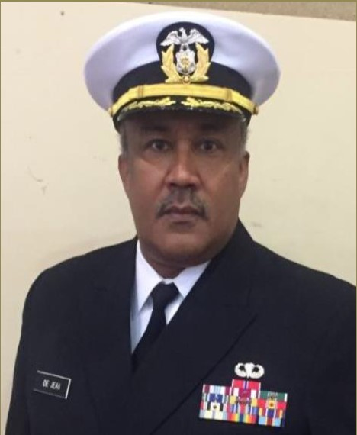

*Captain Preston DeJean: MSCHE Dean's Advisory Board Member, Professor Department of Marine Transportation.*

Captain Preston DeJean joined the States Merchant Marine Academy in March 2011 as a faculty member in the Department of Marine Transportation, Business Division.

Since arriving at the Academy, he spearheaded the creation of the Maritime Law Society; served as Chair of the Self-Study Steering Committee for the 2016 Decennial Reaccreditation; served as Assistant Dean for Academic Support Programs and Interim Academic Dean; and has participated on numerous academy-wide committees. CAPT De Jean recently served as the Associate Dean for Faculty Affairs before returning to the classroom as a Professor in the Department of Marine Transportation.

CAPT DeJean formerly served as a United States Army officer, attaining the rank of Lieutenant Colonel as a Transportation and Logistics Officer with his last assignment with the U.S. Army Surface Deployment and Distribution Command at Scott AFB, IL.

During his tours of service on both active duty and reserve status, he participated in a number of military exercises and operations with duty across the continental United States, Korea, Europe, along with assignments in Kuwait and Iraq in support of Operation Iraqi Freedom.

As a licensed attorney in Louisiana, he practiced law specializing in tax related matters, contracts, bankruptcy, and business consulting. He has also worked in higher education administration as Assistant Vice President for Academic Affairs for the Southern University System in Baton Rouge, Louisiana.

CAPT DeJean holds a Juris Doctor from the Southern University Law Center in Baton Rouge, Louisiana and a Masters of Law in Taxation from Golden Gate University in San Francisco, California. In addition, he has completed studies at the Harvard Kennedy School of Executive Education, receiving a certificate in the Art and Practice of Leadership.

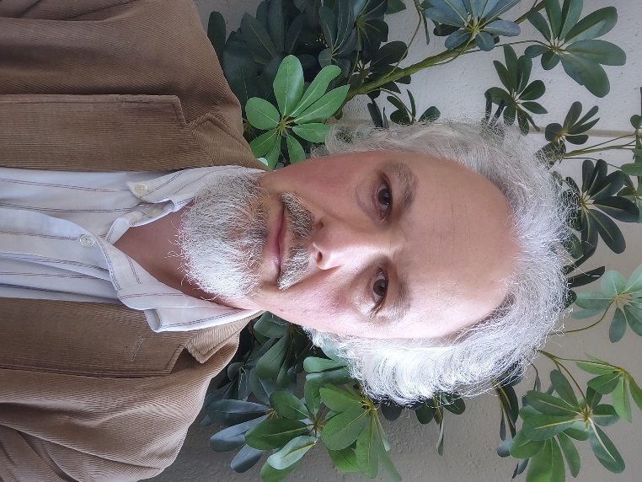

*Dr. Alexander Retakh: Institutional Data Assessment Specialist, Assistant Professor of Mathematics.*

Dr. Alexander Retakh joined USMMA in June of 2016 as an Assistant Professor of Mathematics.  He has taught most of the mathematics and statistics courses in the curriculum and was instrumental in the creation of the Cybersecurity concentration.   He was promoted to Full Professor in 2021.  Dr. Retakh has an interest in the theory and practice of assessment of student learning, having served on various assessment and academic standards committees.  Currently he is the faculty co-chair of the Program Learning Outcomes Committee.  He served as a temporary Director of Institutional Assessment and spearheaded data collection and analysis for the re-accreditation Self-study in 2017-18.

Prior to USMMA Dr. Retakh taught and conducted research in Massachusetts, Texas, and New York.  He received his PhD from Yale University in 2002, specializing in infinite-dimensional algebra and its applications to mathematical physics.

**MSCHE Steering Committee Members/Working Group Chairs**

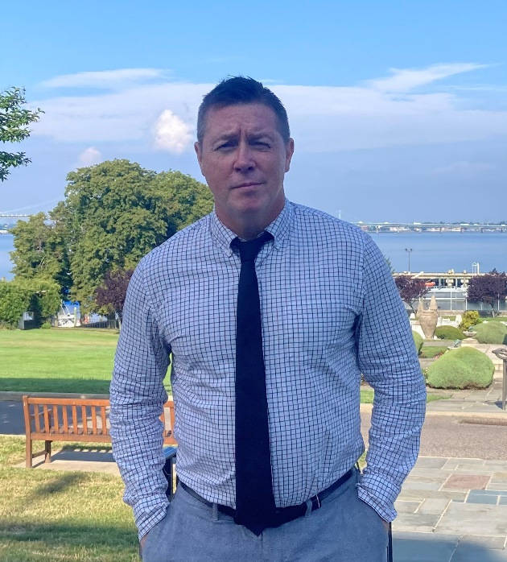

*Mr. Thomas O'Boyle: Steering Committee Member & Standard I - Mission and Goals Working Group Chair.*

Thomas J. O’Boyle has served as the Director of Midshipmen Activities at USMMA since 2021.  Thomas holds a Master of Business Administration from Pace University and a Bachelor of Arts Degree from Hartwick College.   He is currently a Doctoral Candidate in the Higher Education Administration Program at Liberty University.  Thomas has worked in higher education for over 25 years, and has extensive experience in student advising, workshop facilitation, program assessment and evaluation, strategic planning, residential like, supervision, and project management.  Prior to coming to the U.S. Merchant Marine Academy, Thomas has served as the Associate Dean for Students at Five Towns College as well as the Director of Residence Life and Education at the Jewish Theological Seminary in New York City.

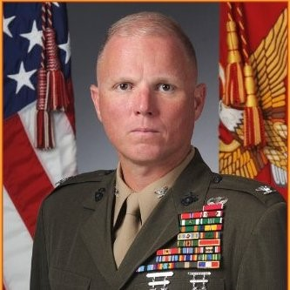

*Captain Patrick Keane: Steering Committee Member & Standard II - Ethics and Integrity Working Group Chair. Director of Leadership and Ethics Development.*

CAPT Pat Keane, USMS is the Director of Leadership Development at the US Merchant Marine Academy.  He is a Colonel in the US Marine Corps (Retired).  He was born in East Meadow, New York, attended Chaminade High School, and earned his commission as a Marine 2nd Lieutenant in 1992 via the NROTC program at Villanova University. Following The Basic School and Infantry Officers Course, he was assigned to 2d Battalion, 2d Marines.  He served as a Rifle Platoon Commander, Combined Anti Armor Team (CAAT) Platoon Commander, and Weapons Company Executive Officer. In addition to a deployment to Okinawa, he participated with the battalion in OPERATION UPHOLD/SUPPORT DEMOCRACY in Cap Haitien, Haiti in 1994.

In 1995, he reported to Marine Corps Recruit Depot (MCRD) Parris Island for service as a recruit training officer. He served as a Series Commander, Company Executive Officer, and Company Commander in Golf Company, 2d Recruit Training Battalion. Following graduation from Amphibious Warfare School in 1999, he reported to the 2d Battalion, 3d Marines.  He served as the battalion S-4, Commanding Officer, Golf Company and Commanding Officer, Weapons Company; he deployed with the battalion to Okinawa twice.  
In January 2002, he reported to 1st Battalion, 1st Special Forces Group (Airborne) as a combat advisor/Marine Liaison Officer to the 2d Philippine Marine Brigade on the island of Basilan, Republic of Philippines for OPERATION ENDURING FREEDOM - PHILIPPINES.  
  
In July 2002, he reported to US Marine Corps Forces Atlantic. He served initially as Aide de Camp to the Commander. He was reassigned as Commander, Task Force Georgia Train and Equip Program (GTEP), leading the effort to train a Georgian tank-mech task force (2003-2004). Upon redeployment, he reported to Coalition Military Assistance Transition Team (CMATT), Baghdad, Iraq for OPERATION IRAQI FREEDOM (OIF) II, serving as operations officer for all combat advisor teams throughout the country (2004-2005).  His last assignment at MARFORLANT was as a Central Command (CENTCOM) regional planner. He graduated from the USMC Command and Staff College in 2006 and the School of Advanced Warfighting in 2007, earning two masters’ degrees.  
  
Following school, he reported to II Marine Expeditionary Force (MEF), serving briefly as the Expeditionary Operations Officer/Current Operations Planner with the G-3. He was reassigned as the Future Operations Officer, G-3, II MEF (Forward), Al Anbar, Iraq for OIF 09 (2009-2010). In March 2010, he was reassigned as Assistant Chief of Staff, G-3, 2d Marine Division. In January 2012, he assumed command of 2d Light Armored Reconnaissance Battalion.  He served as the commanding officer of “The Destroyers” until January 2014.

Following battalion command, he attended the Joint Forces Staff College, completing Joint Professional Military Education Phase II.  He was designated as a Joint Specialty Officer. From 2014 to 2016, he was the Deputy Director, Marine Air Ground Task Force (MAGTF) Staff Training Program (MSTP), responsible for the training and assessment of Marine Expeditionary Brigade and Marine Expeditionary Force command elements in high end warfighting. His final assignment on active duty was as the Assistant Chief of Staff, G-5 (Plans) for U.S. Marine Corps Forces Europe and Africa.  He led a high-performing operations planning teams that developed crisis management, contingency, and engagement plans for a 10,000-person organization across Europe and Africa.  He retired as a Colonel of Marines in August 2018.

Prior to his current role at USMMA, he was a consultant on strategic and operational planning at US Marine Corps Forces South in Miami, Florida.  He assisted in the development of contingency and security cooperation plans for Central and South America and the Caribbean.  He was instrumental in developing the way ahead for enhanced naval integration and interoperability, in both US naval forces as well those of partners. His awards include the Legion of Merit (3), Bronze Star Medal, Meritorious Service Medal (3), Navy-Marine Corps Commendation Medal (2), Army Commendation Medal, Navy-Marine Corps Achievement Medal, and the Combat Action Ribbon.

Colonel Keane is married to the former Adriana Mema of Berat, Albania.  They have four children: Patrick (14), Thomas (12) and twin girls, Audrey and Erin (8).

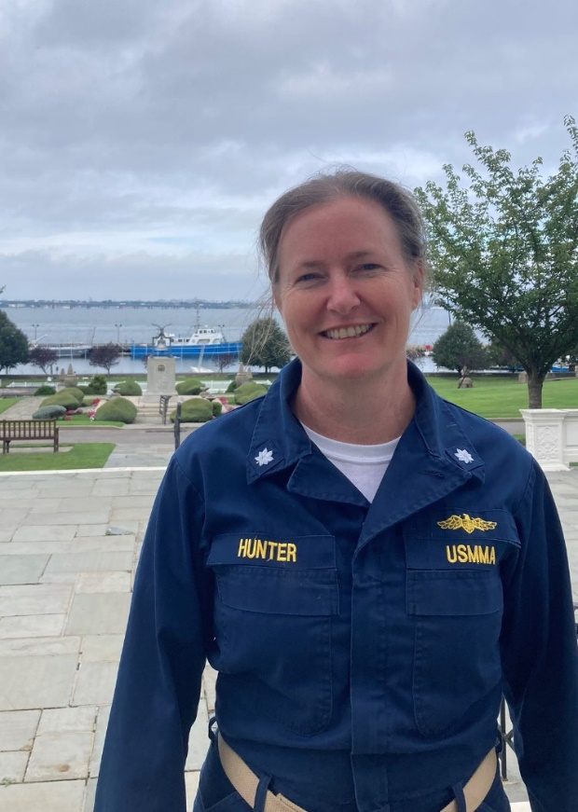

*Commander Carolyn Hunter: Steering Committee Member & Standard III - Design and Delivery of the Student Learning Experience Working Group Chair. Assistant Department Head, Marine Transportation.*

CDR Carolyn Hunter is a native of Oyster Bay, NY.  She attended SUNY Maritime College and earned a Bachelor of Engineering in Naval Architecture, USCG Third Mate Unlimited Tonnage License, and a Commission in the United States Naval Reserve.  She is a graduate of Stevens Institute of Technology where she earned a Master’s Degree in Maritime Systems.  She worked as a Civilian Mariner for Military Sealift Command for 17 years where she obtained an Unlimited Master’s License.  During her time at MSC, CDR Hunter worked as a Shipboard Officer upon Oilers, Ammunition, Cable and Hospital ships; and as Damage Control Officer/Business Manager at Military Sealift Command Training Center East.  She completed 20 years in the US Naval Reserves serving in the Individual Ready Reserve and the Select Reserves.  In 2015 she transitioned to USMMA to become an Assistant Professor of Nautical Science.  She is currently the Sea Year Coordinator and Assistant Department Head of Marine Transportation.  CDR Hunter is also a volunteer Victim Advocate and Advisor for multiple clubs.

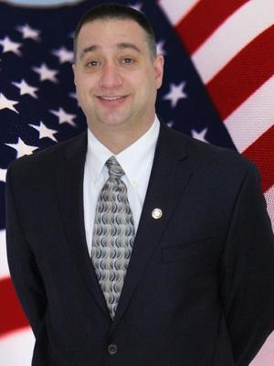

*Coach Michael Notebaert: Steering Committee Member & Standard IV - Support of the Student Experience Working Group Chair. Assistant Athletic Director of Facilities, Head Men’s Baseball Coach.*

A graduate of Ithaca College, Michael Notebaert is entering his 18th year with the program and his 16th as the Head Coach.  
   
In March 2013, in addition to his duties as Head Baseball Coach, Notebaert was named Assistant Athletic Director for Facilities and Events. He is charged with scheduling facility usage, ensuring the facilities are up to date and maintained and assisting in project and event management.  
   
In his 15 years at the helm for the Mariners, Notebaert has become the all-time winningest coach in the history of the program. He has guided Merchant Marine to eleven (11) trips to the Landmark and Skyline Conference Tournament. Four (4) of those playoff berths have resulted in trips to the Conference Finals (2009, 2018, 2021, & 2022). In 2021, Notebaert led the Mariners to their first-ever Conference Title and trip to the NCAA Regionals, where the team lost in the Semifinals and was just two wins shy of advancing to the Division III College World Series.  
   
Under Notebaert, the Mariners have also captured their only two Regular Season Conference Championships. In 2013, the team finishing tied atop the Landmark Conference standings with Catholic University, and in 2021 the Mariners were the outright Skyline Champions. Under the tutelage of Notebaert, the Mariners have had eight (8) seasons with twenty or more wins, including a program record 28 wins in both 2018 and 2019. Notebaert has produced the Academy's first conference Player of the Year in 2013 and only three conference Pitchers of the Year in 2018, 2019, and 2021. Twice he has seen his players tabbed as the Academic Player of the Year for the conference (2018 and 2019). In total, Notebaert has coached a total of seven (7) All-America Selections, two (2) CoSIDA Academic All-Americans, twenty (20) American Baseball Coaches Association (ABCA) All-Region selections, seventeen (17) D3Baseball.com All-Region Sections, twelve (12) ECAC All-Region sections, and fifty-four (54) All-Conference players in his 15 years as the Merchant Marine Head Coach.  
   
Notebaert was named the D3Baseball.com New York Region Coach of the Year in 2021, while also being selected the Landmark Conference Coach of the Year twice (2009 & 2013), the Skyline Coach of the Year once (2021) and was a three-time recipient of the Academy's Bill Omeltchenko Coach of the Year Award (2009, 2012, & 2021). Under Notebaert, the USMMA baseball team has won the ABCA Team Academic Excellence Award seven (7) times. The team has also won the Dean’s Award for highest team GPA at USMMA three times (2011, 2016, and 2018).  
   
Notebaert completed his MBA in Leadership & Management at Dowling College in 2010. He now resides with his wife Veronica, son Andrew and daughter Natalie in East Meadow, N.Y.

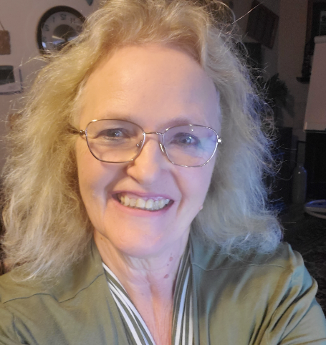

*Dr. Pamela Bryant: Steering Committee Member & Standard V - Educational Effectiveness Assessment Working Group Chair. Chemistry and Physics Lab Manager.*

I began employment with USMMA in March of 2020 as lab manager for the Department of Math and Science.  I moved to Long Island from Brownwood, Texas where I worked for twenty years as a Chemistry professor and Dean of Math and Science at Howard Payne University, HPU.  I graduated from the University of Texas Permian Basin with a BS in Mathematics and an MA in Secondary Education.  I taught high school chemistry, did computer programming and trained horses while my two daughters were in school.  I then, had a computer software business where I trained doctors’ offices to use medical software.  I sold the business and enrolled in a PhD.  program at Louisiana State University where I studied Solid-State Nuclear Magnetic Resonance Spectroscopy of High Spin Nuclei.  I received my PhD. in Chemistry and did a post-doc at MIT in the Chemical Engineering department where I tested the physical properties of Durathan, a polyamide plastic with high mechanical strength and good electrical insulation.   From MIT, I went to Howard Payne University.  At various times during my stay at HPU, I was on the Dean’s Council, the Catalog and Curriculum Committee, the Quality Enhancement Plan Planning council, General Education Committee, the Teacher Education Committee, and the Technology Committee.  I started a Forensic Science Program and an Engineering Science Program with the goal to become ABET approved.  I received the Faculty Member of the Year award while there.  I taught an astronomy class at a local youth prison, taught Biochemistry one summer in Korea and Chemistry one summer in Kenya.  I conducted several summer programs for STEM teachers in the area.  While at USMMA, not only have I been instrumental in keeping the labs orderly and effective but do the PRISM accounting for the department.  I also teach chemistry lecture classes, tutor or help students with research projects during terms when needed.  I am a Mentor, a member of the Candidate Evaluation Board, a member of the Committee on Midshipman & Regimental Affairs and Chairman of the Middle States – Standard V Educational Assessment.

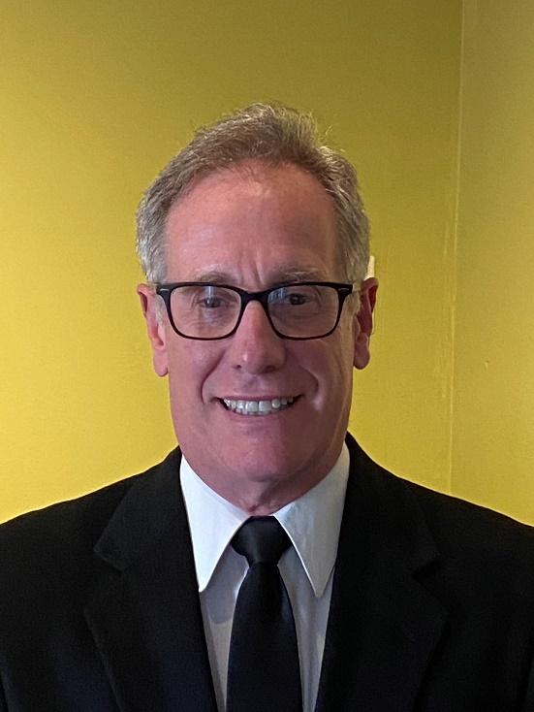

*Captain Peter Kahl: Steering Committee Member &amp; Standard VI - Planning, Resources, and Institutional Improvement Working Group Chair. Associate Professor, Marine Engineering.*

Peter Kahl was born in and resides in New York, where he graduated from the United States Merchant Marine Academy (1979) with a Bachelor of Science degree in Marine Engineering, minoring in marine machinery design. Additionally, Peter obtained an MBA from Hofstra University concentrating in strategic planning and organizational design (1983). Upon graduating Kings Point (USMMA), Peter accepted a commission in the inactive U.S. Navy Reserve and was granted a U.S.C.G license as a third assistant engineer for both steam and motor vessels of unlimited horsepower. Upon graduation he pursued a sailing career in the U.S. Merchant Marine sailing around the world on large container vessels under U.S. flag for 14 years. He upgraded to a Chief Engineers license for unlimited horse power motor vessels. He came ashore as a Port Engineer for Sea Land Services which was at the time the largest shipping company in the world. As a Port Engineer he led, planned and oversaw over 25 major shipyard periods in eight countries worldwide during a 12 year stay at Sea Land. The shipyard periods involved major modifications, complying with regulatory, surveys and life extensions in order to maintain vessels often in excess of 40 years of age. After 12 years ashore working as a Port Engineer, Peter transitioned to the maritime education field working for the Global Maritime and Transportation School (GMATS) at Kings Point. Peter spent 5 years developing training programs for industry professionals and U.S.N personnel most courses were designed to comply with U.S.C.G Standards of Training & Watch Keeping (STCW) requirements. Eventually Peter moved to the full-time faculty at the U.S. Merchant Marine Academy where he has been teaching as an Assistant and Associate Professor since 2010. During his tenure at Kings Point he has led the (ABET approved) programs for the ship production and shipyard management major offered by the Academy. Peter has been heavily involved in the ongoing accreditation reviews by both Middle States and ABET review teams.

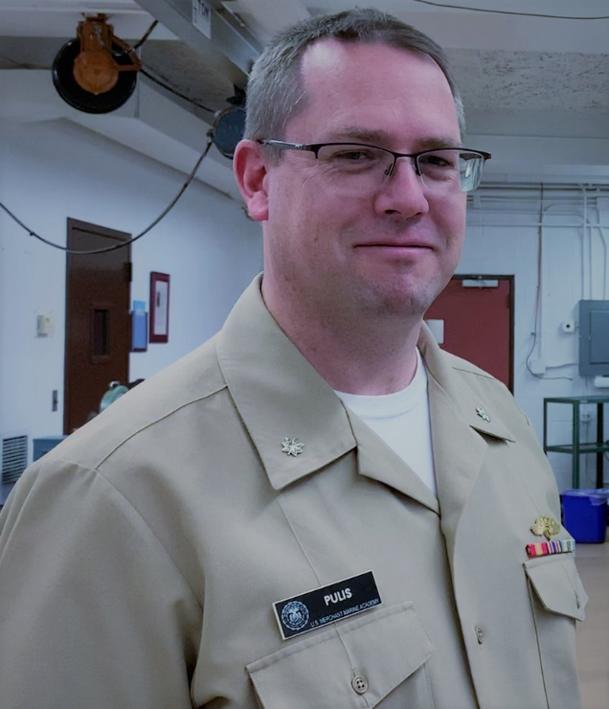

*Commander David Pulis: Steering Committee Member & Standard VII - Governance, Leadership, and Administration Working Group Chair. Assistant Dean of Support Programs, Associate Professor, Marine Engineering.*

David Pulis joined the Dean’s Department in May of 2023, and is currently in charge of Budgets, Textbooks, and IPC issues for the academic departments.  He is also a tenured associate professor in the Marine Engineering Department.  He earned his B.S. degree in Marine Engineering Systems from USMMA in 2000 (Magna Cum Laude), and his M.S. in Marine Engineering in 2009 from USMMA.  CDR Pulis is a retired commander in the US Navy Reserves (SSO Program), a commander in the United States Merchant Service (USMS), a licensed Professional Engineer in the State of New York, and holds a current 2nd Assistant Engineer Unlimited Horsepower U.S. Coast Guard License.

CDR Pulis began his professional career as an engineer working as a U.S. Navy contractor in Washington, DC.  For over five years, he worked in PMS 377 with the Hull Machinery & Repair group.  He worked on contracts and design for LHD 7, LHD 8, LHA-R and LCAC.  CDR Pulis moved to New York in 2005 to teach engineering at the State University of New York Maritime College.  He taught courses in shipboard systems and propulsion, refrigeration, electrical, thermal processes, engineering graphics, and computer engineering. In 2010, CDR Pulis moved from SUNY Maritime to the United States Merchant Marine Academy as an assistant professor. He has taught a variety of courses at USMMA in both the Marine Engineering and general engineering courses.  While at USMMA, CDR Pulis has also made multiple training cruises aboard the T/S Kennedy, T/S State of Maine, T/S Empire State VI, T/S General Rudder, and T/S Kings Pointer.  In 2017 he accepted a position in the Dean’s department and continued to teach in the Marine Engineering Department.  In 2020, CDR Pulis moved back into the Marine Engineering Department as the Assistant Department Chair.  CDR Pulis was one of the major facilitators in the ABET self-study report for reaccreditation while in the assistant department chair.

CDR Pulis took a commission into the US Navy reserves upon graduation from the Merchant Marine Academy and retired with over 22 years in the MMIRRG, SELRES and SSORG programs.  CDR Pulis has sailed on many commercial and Military Sealift ships with this program.  CDR Pulis became a licensed Professional Engineer in Naval Architecture and Marine Engineering for the State of New York in 2012 and has continued to keep his license active.