**CONGRATULATIONS TO OUR GRADUATING SENIORS! **

**Zoe Chang**

**Tanner Conner**

**Garrett Lawlor**

**Gemma Nguyen**

**Maddie Talecki**

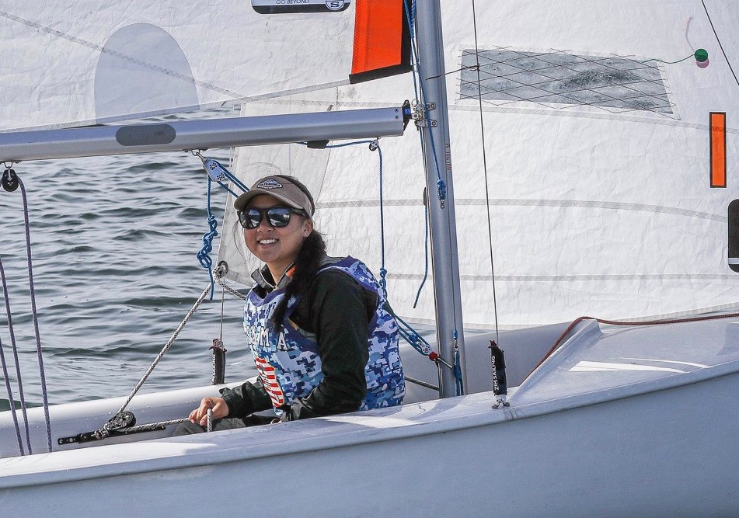

**Name:** **Zoe Chang**

**Hometown:** San Marino, CA

**Degree:** Marine Transportation & Logistics USCG Third Mate Unlimited Tonnage License

**Teams:** Dinghy Sailing (3 years), Tugboat Club

**Regimental** Regimental Waterfront Executive Officer

**Position:** Regimental Waterfront Operations Officer

**Coach Comment:** During the fall of her sophomore year, Zoe joined the team as a walk-on who had never sailed before. Over the past three years, she has developed into one of the best crews on the team. This transformation is no doubt due to her commitment and perseverance. As a testament to this, Zoe has represented Kings Point as a starting crew in every Coed Conference Championships since her first season on the team.

Zoe is not only an accomplished crew, but also an extremely hard-working individual outside of the Waterfront and Athletics. She was also nominated for the Academic All-American and the Academic All-Conference Teams for the 2018-2019 year. Her intensive work ethic - on the water, in the gym, and as a student - is evident in everything she does. Zoe is well-respected among the team for her personality and her hard-working drive to make herself and the team better. The hard work and dedication that Zoe showcases in her daily life will not be forgotten. - Coach McBrien

**From the Athlete:**

**What has being on the team meant to you?** Joining the Dinghy team not only allowed me learn a new sport and gain new friendships, it also opened many other doors for me down at the Waterfront. Joining this team was one of the best decisions I've made, and I will be forever grateful for every sailor, coach, and waterfront staff who has supported and helped me along the way.

**How has being part of the Waterfront and Dinghy Sailing Team changed you and helped you grow as a person?** Joining the team as a walk-on and having never been on a sailboat, I never expected to formulate such a love for college sailing. Although my senior season was cut short, I will forever be thankful for this sport as it has allowed me to make lifelong friendships and unforgettable memories. Reflecting on the last few years, I've realized that regatta standings and team rankings will come and go, but the life lessons of determination, teamwork, and resiliency will last a lifetime.

**What is your favorite team memory?** Three years of sailing on the MBO at Manhasset Bay Race Week, where true friendships are put to the test. Only through teamwork and pure mental toughness may the best MBO crew succeed. "Whatever happens this race, we're still friends" -Garrett Lawlor, MBO skipper

**What will you miss most about the Waterfront and the Dinghy Team?** Hanging out with Cooper, the dog ☺

**What do you view as your greatest athletic accomplishment while at USMMA?**

Individually, I believe my greatest accomplishment was being nominated for the 2018 ICSA Academic All-Americanteam. Throughout the years, I've had to learn to balance my time between the waterfront, academics, and the regiment and I am happy with what I've been able to achieve. I believe my greatest **team**accomplishment was placing in the top five for three years in a row on the MBO at Manhasset Bay Race Week. This feat would not be possible without my skipper MIDN Lawlor and deckhand/steward MIDN Comer. Sailing the MBO has taught us hard work, dedication, and the refusal to give up can lead to great victories.

**What are your post-graduate plans?** Wherever life takes me.

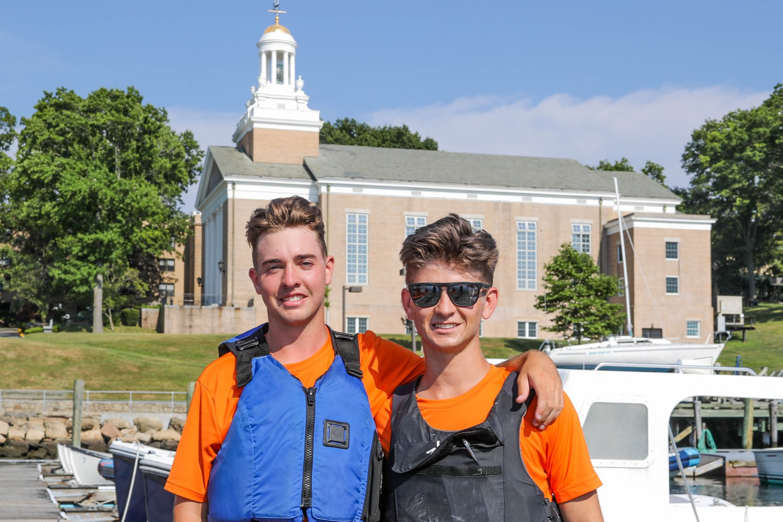

**Name:** **Tanner Comer**

**Hometown:** Indian Harbour Beach, FL

**Degree:** Marine Transportation USCG Third Mate Unlimited Tonnage License

**Teams:** Dinghy Sailing (3 years), Tugboat Club

**Regimental**

**Position:** Regimental Training Vessel Chief Mate

**Coach Comment:** Tanner is one of our most light-hearted and outgoing sailors on the team. He is a versatile team player, typically skippering but always volunteering to stand in as a windy crew for practice or at events. He has worked hard to refine his skills as a skipper over the past few seasons. He notched two top 10 divisional finishes this past fall and was poised to be a strong candidate at the prestigious Engineer’s Cup trophy this spring. In his free time, Tanner is very active in other aspects of the Waterfront, from serving as the Regimental Training Vessel Chief Mate to his involvement in the Tug Club.

In addition, Tanner is always looking for ways to improve the culture of the team. Whether it be after practice, in long van ride conversations, or at team dinners, he consistently tries to make sure every individual is included. As a die-hard Florida native, his only flaw might be an acute sensitivity for any temperatures under 75 degrees. Tanner has had an overwhelmingly positive impact on the team and his personality and presence on the team will be sorely missed. - Coach McBrien

**From the Athlete:**

**What has being on the team meant to you?** It has meant quite a lot for me to be a part of the Dinghy Team. It has changed by life for the better and allowed me to meet great lifelong friends and make incredible memories.

**How has being part of the Waterfront and Dinghy Sailing Team changed you and helped you grow as a person?**

The work ethic that I have developed from learning how to improve as a skipper has helped me to grow in other aspects of my life.

**What is your favorite team memory?** One of my favorite Dinghy Team memories was racing the MBO, one of the finest sailing vessels in America, with Garrett and Zoe at Manhasset Bay every year.

**What will you miss most about the Waterfront and the Dinghy Team?** I will miss sailing with my friends and traveling to regattas together the most about the KP Waterfront and the Dinghy Team.

**What do you view as your greatest athletic accomplishment while at USMMA?** One of my greatest personal accomplishments was getting a 3rd place podium finish at the very competitive Princeton Fall Open.

**What are your post-graduate plans?**

After graduation, I currently plan on working on ships for my career.

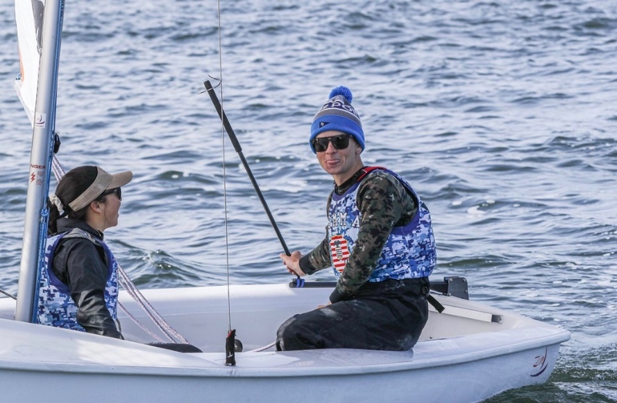

**Name:** **Garrett Lawlor**

**Hometown:** Sarasota, FL

**Degree:** Marine Transportation USCG Third Mate Unlimited Tonnage License

**Teams:** Dinghy Sailing (4 years)

**Regimental**

**Position:** Regimental Waterfront Executive Officer Regimental Waterfront Operations Officer

**Coach Comment** Garrett has made an impressive impact on the Dinghy Team, both as an athlete and a leader.

He has been at the top of the game since joining the team during his freshman fall. He immediately took the role as one of the starting crews during his first season, and was part of the starting line that lead the Kings Point team to a 15th place at Coed Nationals in 2017. Eventually, Garrett transitioned into the role of a skipper, and through strong work ethic and dedication, he developed into one of our starting drivers during his junior and senior years. During his senior fall, he helped to lead our team to a successful season, highlighted by an 8th place finish at our Coed Conference Championships.

While serving in the capacity of Team Captain for the past two years, Garrett has done an incredible job leading by example, innovating our team culture, and inspiring his teammates to continue improving every time we hit the water. He arrives to practice with a goal for each day and week; this work ethic has not only helped to expedite his own growth as a sailor, but has similarly instilled this notion of continual improvement on his teammates as well. Whether it be during practice, team meetings, or through his van ride DJ skills, Garrett never fails to brighten the day of his teammates. - Coach McBrien

**From the Athlete:**

**What has being on the team meant to you?** Being part of the Dinghy team means competing with my friends at practice and regattas while making memories that I won’t forget. My time as an student-athlete at the Waterfront has changed my life forever.

**What is your favorite team memory?** Some of my favorite memories include sailing at Dartmouth on Columbus Day weekend during my senior fall and traveling to a regatta at Hobart my freshman year. Another favorite experience was sailing the MBO at Manhasset Bay Yacht Club, possibly the toughest competition I faced in my entire college career. It can be described as a roller coaster of emotions, both during the 3 days of racing as well as each year.

**What will you miss most about the Waterfront and the Dinghy Team?** All of the memories made, the long van rides with the team, the endless roll tacks, and the chance to be able to sail with my friends everyday will be some of the things I’ll miss most about the Dinghy Team. ☺ <3

**What do you view as your greatest athletic accomplishment while at USMMA?** One of my greatest achievements while on the Dinghy Team was qualifying for Nationals freshman year and making it to the Finals at nationals. Also, probably most importantly, being able to 3-peat as the youth champion for the MBO fleet during Manhasset Bay Race Week.

**What are your post-graduate plans**? Looking forward to the future, I plan to work on commercial vessels. I’ll also probably be watching college sailing scores for the rest of my life thinking back to how our team definitely would’ve gotten to Nationals my senior year if we had the chance to prove our skills.

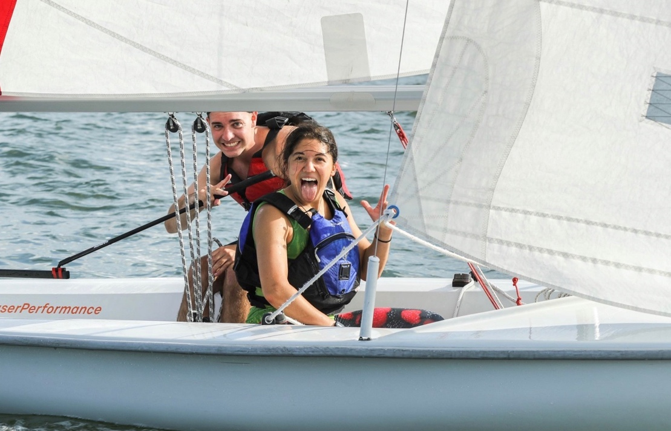

**Name:** **Gemma Nguyen**

**Hometown:** Frisco, TX

**Degree:** Marine Logistics and Security USCG Third Mate Unlimited Tonnage License

**Teams:** Dinghy Sailing (3 years)

**Regimental** Band Company Commander, Flight Deck Platoon Commander

**Positions:**

**Coach Comment** After sailing on the Dinghy team during her freshman and junior years, a few of her Senior teammates convinced Gemma to come back to the team for her Senior Year. I think I am not only speaking for myself, but for the whole team, when I say this – we are extremely happy that she did! She joined the team with no sailing experience, and over the course of her college career (even just this past year), Gemma has made large gains as a sailor and athlete. She finished her senior fall season with a 3rd place podium finish at the Nevins Trophy. She worked her way up the ranks on the team as a crew this past fall, and was slated to start at the first several events of our spring (before the season got cut short).

Gemma has an ever-positive and outgoing personality. Every single day, she always comes to practice with a smile and happy greeting. She is an extremely hard worker; she often asks when the next workout is going to be posted and stays after practice to seek personal critiques to improve her game. She never fails to bring a smile to the face of anyone on the team she talks to. Gemma truly exemplifies the values of integrity, team work, and Kings Point to a tee. - Coach McBrien

**From the Athlete:**

**What has being on the team meant to you?** I'm so glad for all the people I got to share my senior season with. Shoutout to Patrick Modin for having an awesome personality, Tommy Green for putting up with my inability to sail in high winds, Zaracha for having my favorite name to mispronounce, Maddie for being a great girl to confide in, Zoe for being my roomie on my one and only travel regatta, and lastly, to Tanner and Garrett for convincing me to come back <3 LOVE YOU GUYS!!!

**How has being part of the Waterfront and Dinghy Team changed you/helped you grow as a person?**

To be honest, dinghy sailing also really helps with some of the Rules of the Road questions on the license exam.

**What is your favorite team memory?** One of my favorite memories on the Dinghy Team was sailing with the best skipper in existence: Tanner Comer.

**What will you miss most about the Waterfront and the Dinghy Team?** One of the things I will miss the most about the KP Waterfront and the Dinghy Team is getting to hang and sail with my senior friends.

**What are your post-graduate plans**? After I graduate, I want to sail deep sea on my license.

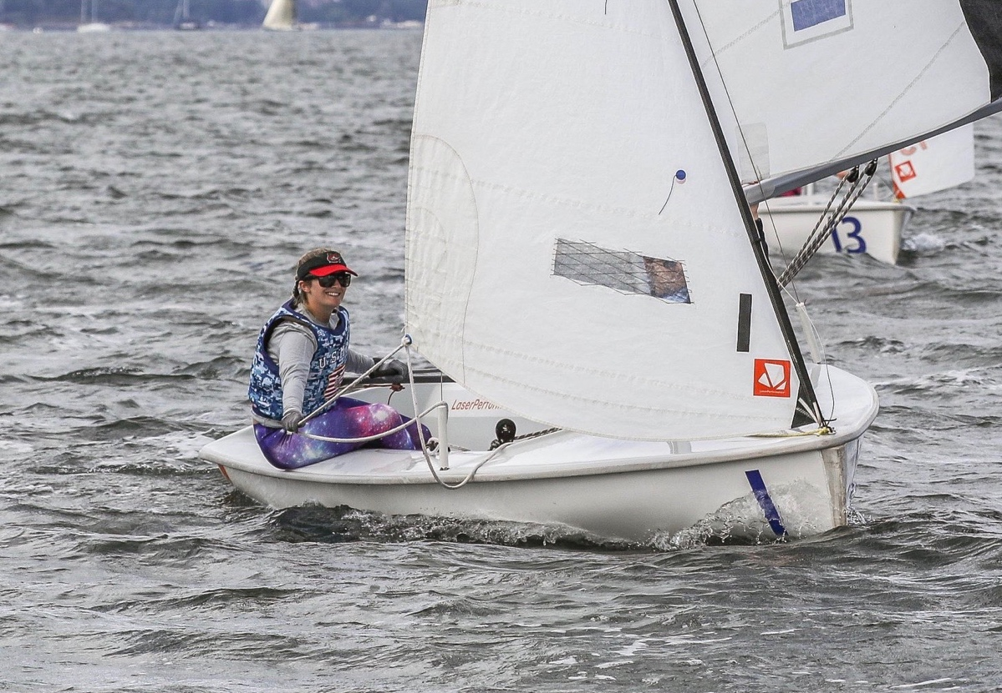

**Name:** **Maddie Talecki**

**Hometown:** Doylestown, PA

**Degree:** Marine Engineering and Shipyard Management USCG Third Asst. Engineer Unlimited Horsepower License

**Teams:** Dinghy Sailing (4 years)

**Regimental**

**Position:** Company Human Relations Officer

**Coach Comment:** Maddie has been an impact player on the Dinghy Team throughout her college sailing career. She joined the team without ever setting foot on a dinghy before. Over her four years on the team, Maddie has played a role in many aspects of the team. She was a strong force on our Match Race team during her sophomore and junior fall seasons, which included a 4th place finish in the Conference Championships her sophomore year. She has grown immensely as one of our crews on the Coed team as well, including sailing in three Conference Championships and starting in our first events of the Spring 2020 season. Maddie has also been an instrumental part of building our Women’s team. Her skippering debut at the KP Women’s Open was a major achievement in two ways. This was the first double-handed women’s event in which KP had competed in 13 years! In addition, for Maddie, starting as a skipper is quite an accomplishment in and of itself, after never having sailed just four years prior.

All of the above showcases Maddie’s impressive commitment, determination, and passion for the sport of sailing. She is often one of the first sailors off the dock each day at practice, always trying to get a few extra minutes of on-the-water time. Maddie rarely ever misses a practice, team meeting, or workout. Her hard work and dedication will be sorely missed, but it goes without saying that we are sure she’ll be going on to great things. - Coach McBrien

**From the Athlete:**

**What has being on the team meant to you?** It has been a great experience to be part of the Dinghy Team. I am happy to have a new hobby to enjoy throughout the rest of my life.

**How has being part of the Waterfront and Dinghy Sailing Team changed you and helped you grow as a person?**

I learned how to skipper which was really challenging for me.

**What is your favorite team memory?** My experience as part of the Match Race team my sophomore year was one of my favorite memories on the Dinghy Team.

**What will you miss most about the Waterfront and the Dinghy Team?** I will miss the access to amazing boats and plenty of people to sail with the most about the Waterfront and Dinghy Team.

**What do you view as your greatest athletic accomplishment while at USMMA?** Skippering the double-handed Women’s regatta at Kings Point was likely one of my greatest accomplishments while on the team, especially with having never sailed before USMMA.

**What are your post-graduate plans?** After graduation, I am planning to sail on my 3rd Engineer’s License.